

TRAVEL POLICY AND TRAFFIC MANAGEMENT PLAN

Version
1

Last Updated
July 2024

Adopted by School
September 2024

Next Review
July 2026

Traffic Management Plan July 2024

1

TRAVEL POLICY AND TRAFFIC MANAGEMENT PLAN

1. INTRODUCTION
This document has been prepared to inform employees, pupils, parents and carers, and others who come onto the site, including visitors (both pedestrian and in vehicles), about the site rules concerning pedestrian and vehicle management.
Worle Village Primary School takes the health and safety of all site users very seriously. It is therefore imperative that individuals take care, when in the school grounds or within the vicinity of the school and follow instructions to reduce the risk of injury. If there are any concerns about traffic safety, they should be reported to the leadership team.
We urge all site users to read this document carefully and act in accordance with the instructions which constitute site rules. Staff and pupils in breach of the site rules may be subject to disciplinary action.
Copies of this document are available to school staff, pupils, parents and carers, on our school website at https://www.worlevillage.n-somerset.sch.uk/policies/
The document will be reviewed annually and awareness raised regularly through events, assemblies and school meetings.
In addition to the instructions in this document, the school has also undertaken a risk assessment which is recorded in Appendix A.
For further information, please contact Worle Village Primary School, tel.: 01934 512300 or via email: office@worlevillage.n-somerset.sch.uk

2. SCHOOL LAYOUT / ACCESS
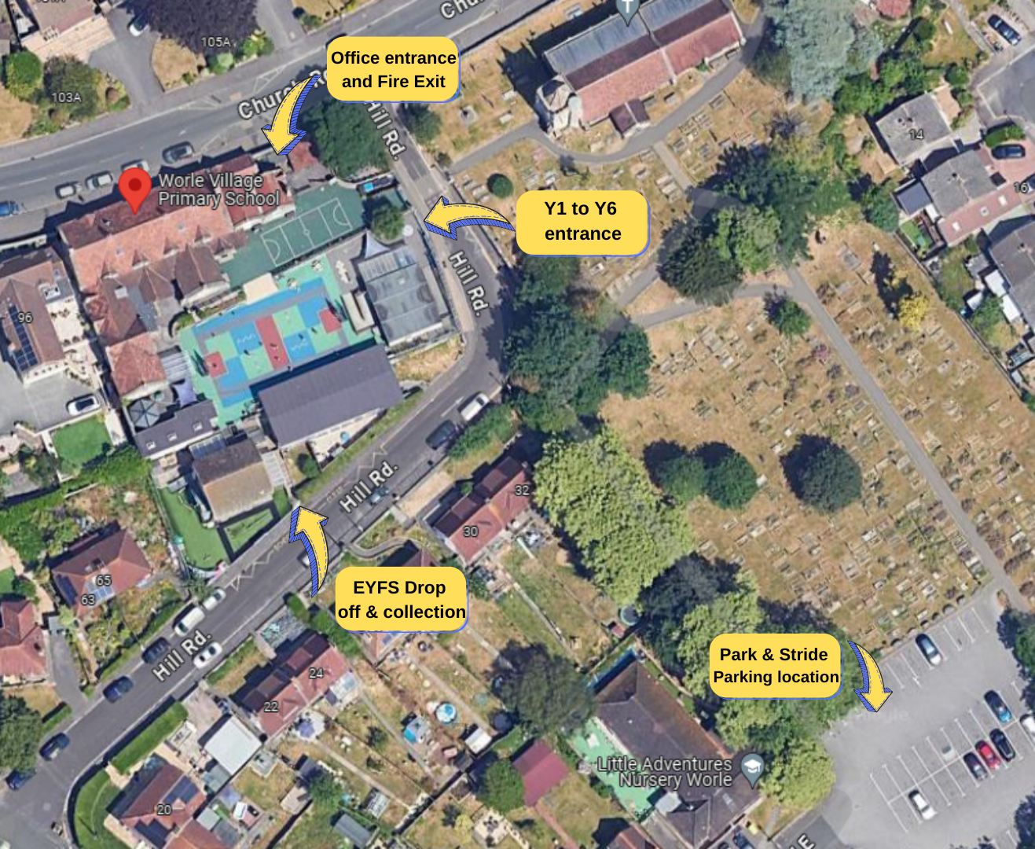

3. TIMES OF THE DAY
Classes | School Starts | Break | Lunch | PM Session Ends
Bluebird (Year EYFS/1) | 08:50 | 10:15-10:30 | 12:00-13:00 | 15:15
Flamingo (Year 1/2) | 08:50 | 10:15-10:30 | 12:00-13:00 | 15:15
Kingfisher (Year 2/3) | 08:40 | 10:30-10:45 | 12:00-13:00 | 15:15
Penguin (Year 4) | 08:40 | 10:30-10:45 | 12:30-13:30 | 15:15
Robin (Year 5) | 08:40 | 10:30-10:45 | 12:30-13:30 | 15:15
Puffin (Year 6) | 08:40 | 10:30-10:45 | 12:30-13:30 | 15:15

4. PEDESTRIANS
At the Year 1 to 6 entrance there are Barriers and Parking Buddies placed and removed once school gates are shut. They are placed so as not to obstruct the road. Where there are pavements, pedestrians should make sure that they use these safely and avoid spilling onto the road. Pupils walking in groups should take this into account and allow others to pass safely. On Hill Rd there are markings on the road instead of pavements.
Pedestrians should only access the school from the designated entry points either the top gate (office entrance), side gate (Y1 to 6 entrance) or the lower gate (EYFS entrance.) Pedestrians need to recognise that these may be next to main roads that will be in use during peak times and should exercise caution.
Pedestrians should follow the local footpaths and enter the school site using the main gates.

5. PUPILS
It is very important that pupils set a good example to others, particularly in the spirit of being a safe school. There are a number of site related issues that learners should be aware of:
- Pupils and staff should be particularly aware that members of the public may try to enter school premises via the top gate. Pupils and staff are encouraged to remain vigilant and keep the gates closed wherever possible.
- When entering the school grounds pedestrians should walk. Scooters and bicycles should not be ridden on school grounds. This will avoid accidents and will make everyone more aware of what is happening around us.
- Anyone arriving at school by bicycle or scooter must enter the grounds via the side gate. Cycles and scooters should be left in the racks by the side gate on the middle playground.
Drop off
For learners who attend breakfast club or after school club and who are dropped off or collected by their parents/carers:
- All children and parents/carers should enter the school via the top gate. They may need to buzz and wait for a staff member.

6. STAFF
The premise does not have any staff parking allocated. Staff are expected to park responsibly with courtesy for the residents of the area. Like our Pupils staff are encouraged to Park & Stride to help ease the congestion around the school and also to fit in with our healthy school ethos. All staff will hold appropriate insurance and MOT documents and will present these if taking children in their cars.

7. VISITORS
We ask that visitors park responsibly with courtesy to the local residents. Access into the school is only permitted from the top gate. All visitors must report to reception and sign in before going anywhere in the school. The office staff will share safeguarding and fire procedures with all visitors. On departure, visitors should sign out at reception and leave the building by the top gate. There is a button on the left-hand side as you go up the stairs, that will release the gate.
If visitors need any advice on access or parking before their visit, please contact the school office, Tel.: 01934 512200 or office@ worlevillage.n-somerset.sch.uk.

8. SCHOOL ACTIVE TRAVEL POLICY
We actively encourage our pupils and staff to walk, park & stride, scoot or cycle to school. We know that this impacts physical and mental wellbeing positively. Our pupils and staff are also passionate about our local area and following active travel helps keep the local air cleaner and our streets free from congestion.
To support this policy, we use Modeshift STARS to update and monitor our school travel plan and we use the WOW Living Tracker system everyday to encourage more children to travel actively to school. We also provide support through the following:
- Bikeability training
- Pedestrian lessons
- Cycle parking
- Scooter parking
- Providing details of public transport
- Providing details of nearby Park & Stride location

9. SCHOOL ACTIVE TRAVEL POLICY – WHAT WE ASK OF PARENTS & PUPILS

- Ensure your child(ren) walk or ride sensibly and safely to and from school, and to push bikes and scooters onto school grounds.
- Ensure that bicycles and scooters are roadworthy and properly maintained.
- Consider providing your child(ren) with a cycle helmet.
- Use public transport if possible.
We understand that sometimes there is no alternative to driving to school. Here are some options we encourage:
- Where a car must be used, we ask parents to use our Park & Stride car park located at Hill Rd East. Children and parents can then walk up through the Church.
- If you do park near the vicinity of the school please do so legally and safely with respect for our neighbours and local residents. It is not acceptable to park or wait on double yellow lines, on school zig sags or across residential driveways for any period of time.

10. SERVICE VEHICLES / DELIVERIES
Drivers of service vehicles should press the buzzer at the top gate to advise the nature of their visit and get clarification on where they can park. Drivers need to be aware of the road restrictions and double yellow lines around the school.

11. COACHES
Access for coaches is very difficult due to the narrow road and no turning capacity. Therefore, when the school books a coach we arrange for them to park on Church Rd.
The coach should be at a complete stop before allowing learners to get on or off.

12. DISABLED ACCESS
Pedestrian access is via the top playground side gate or the Y1 to Y6 lower playground side gate. There is limited access into the school as there are steps leading to most access routes. More details can be found on the Schools Accessibility Plan.
If visitors, staff or learners require information on access, they should contact the school office. Tel.: 01934 512200 or via email: office@ worlevillage.n-somerset.sch.uk.

13. OUTSIDE THE SCHOOL GROUNDS
The school accepts that parking near the school is not easy. Parking indiscriminately, such as mounting pavements, double parking, stopping on any yellow lines or zig zags, obstructing access points and parking near junctions causes danger to pupils, staff, parents and carers, and other road users. Accidents can arise if views are obstructed or pedestrians have to negotiate between parked vehicles. In addition, the roads can become congested which results in frustration and delays.
Please act responsibly by parking as far away from the school as possible to keep the everyone at Worle Village Primary School, local residents and other road users safe. Emergency Services need to be able to access the school and surrounding houses at all times.

14. MANAGEMENT
Key to the ongoing monitoring of the plan is the role of school managers and other staff. All staff have a responsibility to make sure that they are acting in such a way as not to compromise the health and safety of themselves or others.

Supervision
There is daily supervision at the end of the school day by senior leaders, learning mentor, class teachers and/or support staff around the playground as the children are being dismissed.
Monitoring of compliance against this plan
In addition to the supervision arrangements in place, the Senior Management Team will carry out site inspections to view practices.
Where issues arise with vehicular access these will be dealt with or escalated by the responsible member of the Senior Management Team. The Senior Management Team will be responsible for addressing the conduct of all where this is not consistent with the requirements of this plan.
Non-Compliance
If there are concerns or incidents that constitute non-compliance, appropriate action will be taken. This includes possible disciplinary action and reports going to the Headteacher and the Board of Governors, which may result in investigative action.

Review Date: July 2026

WORLE VILLAGE PRIMARY SCHOOL

Appendix A: Traffic Management Risk Assessment
School: Worle Village Primary School |  |  | Date risk assessment completed: XXXXXX
Activity/activities: Access to the school during the school day |  |  | Risk Assessment completed by:
Significant hazards | Who might be harmed? | Control  Measures |  | Action by who? | To be done by (date) | Date  Actioned
Significant hazards | Who might be harmed? | Already in place | Additional measures required | Action by who? | To be done by (date) | Date  Actioned
- Litter  - Road obstructions  - Parking Buddies  - Bad Weather  - Poor conditions of walkways/roads on site causing slips trips or falls | Staff  Pupils  Visitors  Contractors  Public |  |  | Premises Manager

Traffic Management Plan October 2023 8

